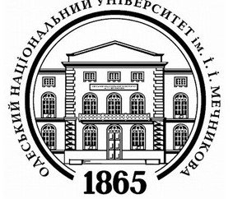 | 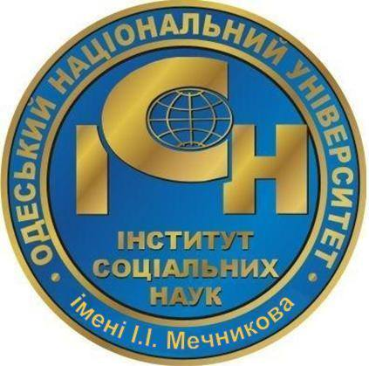 | 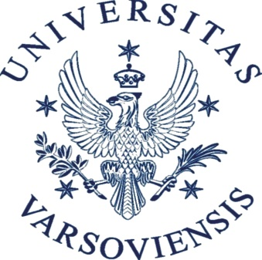 | 

INSTITUTE OF SOCIAL SCIENCES, ODESA MECHNIKOV NATIONAL UNIVERSITY
STUDIUM FOR EAST EUROPEAN STUDIES, UNIVERSITY OF WARSAW
Dear colleagues!
We are pleased to invite you to take part in the International Scientific Conference
SOCIAL AND POLITICAL TRANSFORMATIONS IN CENTRAL AND EASTERN EUROPE (1917-2017): FACTORS, ACHIEVEMENTS, PROBLEMS,
which will be held on
June 28-29, 2017
at the Institute of Social Sciences, Odesa Mechnikov National University
(Odesa, Frantsuzsky Boulevard 24/26)
The conference aims to present scientific results of studies on social and political transformations that have taken place in the states of Central and Eastern Europe for the last 100 years.
The conference is dedicated to discussion and analysis of fundamental social and political theory problems: subjectness of the actors in social and political systems, agents of social change, dynamics of hierarchy of values, directions of memorial strategies, postmodern strategies in the modern communities etc. In the practical dimension, the fundamental transformations of social and political systems, social order, geopolitical configurations, value orientation and communicative strategies in the CEE region pose a lot of questions about current forms of social systems in the areas under research. Interdisciplinary approach to the study of social and political transformations in the region as well as the participation of scientists from CEE should provide multidirectionality of views. Specialists in International Relations, Political Science, History, Sociology, Education and Culture are invited to participate.
Focus areas:
I. Methodology and research methods of social transformations
- ratio of theoretical knowledge and empirical research in practical analysis of «social changes»; agents of social change;
- methodological approaches to the analysis of systemic transformations;
- ways to consider national specifics of social and political systems; research methods of the «social standards» in the context of retrospective and prospective analysis of political systems transformation pattern;
- modern communicative strategies, new information influences and wars in the current social and geopolitical contexts;
- regional political process: functioning of political phenomena;
- local political tradition and global transformations;
- regional political system: assessment criteria and methods of their distinguishing;
- historical and sociological research methods in political science and forms of their use.
II. Regional transformations: social practices and political administration:
- Dynamics of social values and norms; patterns of social and political development and their practical implementation during XX-XXI centuries;
- collective memory in the context of the politics of memory; directions of memorial strategies in public practice and in the policy on nation-states;
- symbolic politics and social construction of the past;
- particular aspects of systemic transformations in CEE states;
- practices of social adaptation in the context of global transformations;
- development of participatory democracy: local, regional and national levels;
- new social media, social movements and forms of activity under conditions of social changes.
Working languages: English, Russian, Ukrainian.
To participate in the conference it is necessary to send the application (titled «last name_application») and the abstract to the Organizing Committee by March 1, 2017.
The application should contain (see Annex): general information about the author, including name of the workplace, current position, academic degree and title, postal address with the postcode, mobile number for connections;
The abstract should contain the problem formulation, the main points and the conclusions. The abstracts will be published in the Collection of materials before the start of the conference.
The volume of the abstract – 1500-2000 characters (including spaces).
We invite to send the applications and the abstracts by March 1, 2017 to the e-mail: Maryna Symenihina <marinushka13@ukr.net>
The Organization Committee of the conference reserves the right to select the received materials to include in the program.
Terms and Conditions:
The registration fee – 260 UAH (10$).
(The registration fee includes the cost of program materials, publishing of the collection of materials, participation in all activities provided by the program of the conference).
We kindly ask the participants to cover their travel, accommodation and food expenses!
Attention! Registration fee should be paid only after receiving the invitation to the conference. Bank details for the payment and the due date will be provided in the invitation. After the payment the copy of check should be sent to the following e-mail – svkoch@mail.ru
Materials of the conference will be the basis for special issues of the «Bulletin of Odesa National University»: 1) Political Science, 2) Sociology. The journal is specialized in political science and sociology. It is included to the scientific database Index Copernicus. The full articles should be submitted by September 1, 2017. The issues will be published in December 2017.
Requirements for arranging the article (see Annex 1 and Annex 2).
Address of the Organizational Committee: Odesa – 65058, Frantsuzsky Boulevard 24/26, Odesa Mechnikov National University, Institute of Social Sciences
Brusylovska Olga (brusylovska@gmail.com);
Koch Svitlana (svkoch@mail.ru);
Knyazeva Olena (knyazeva.elena@bk.ru);
Lychkovska Oksana (lychkovska@mail.ru);
Popkov Vasyliy (vpopkov@inbox.ru).

APPLICATION
for the participation in the International Conference

SOCIAL AND POLITICAL TRANSFORMATIONS
IN CENTRAL AND EASTERN EUROPE (1917-2017):
FACTORS, ACHIEVEMENTS, PROBLEMS
June 28-29, 2017
Author`s photo
(portrait)

size 3х4

format jpg

Name, Last name
Academic degree, Academic title
Current position and name of the workplace
Phone number
E-mail
Need for technical equipment
Need to book hotel/hostel
Title of the report
Focus area (point I or II)
ABSTRACT (1500-2000 characters)

